# CGP API Shortcodes

Last updated: June 23, 2021

Custom WordPress plugin that houses WordPress shortcodes that interact with the CGP API

Directory Location: /wp-content/plugins/cgp-api-shortcodes/

## 1 - Settings

* WP-Admin -> Settings -> CGP API Settings

Provides an interface to change the API endpoints

| **Name** | **Default** |
| --- | --- |
| API URL - Featured | https://bkbu8krpzc.execute-api.ca-central-1.amazonaws.com/staging/featured |
| API URL - Foundational | https://bkbu8krpzc.execute-api.ca-central-1.amazonaws.com/staging/foundational |
| API URL - Search | https://app-stage.geo.ca |
| API URL - Search Result | https://app-stage.geo.ca/result |

## 

## 2 - Shortcode Usage

### [cgp-api-ft-data]

**Description:**

Display featured or foundational records on the WordPress sites using the CGP API

**Parameters:**

| **Name** | **Description** | **Valid Params** | **Default** |
| --- | --- | --- | --- |
| lang | Language to display result in | string ‘en’ | ‘fr’ | en |
| theme | Theme to filter results by | string  Valid theme name (e.g. ‘legal’) | none |
| type | Type to filter results by | string ‘featured’ | ‘foundational’ | featured |
| showpagination | Include pagination? | string  ‘true’ | ‘false’ | true |
| numitemsperpage | Number of items to show per page when pagination is included | integer Any positive integer | 5 |
| maxitems | The maximum number of records that will be displayed | integer Any positive integer | 20 |

**Example:**

[cgp-api-ft-data lang=’en’ theme=’legal’ type=’featured’ showpagination=’true’ numitemsperpage=3 maxitems=10]

**Screenshot:**

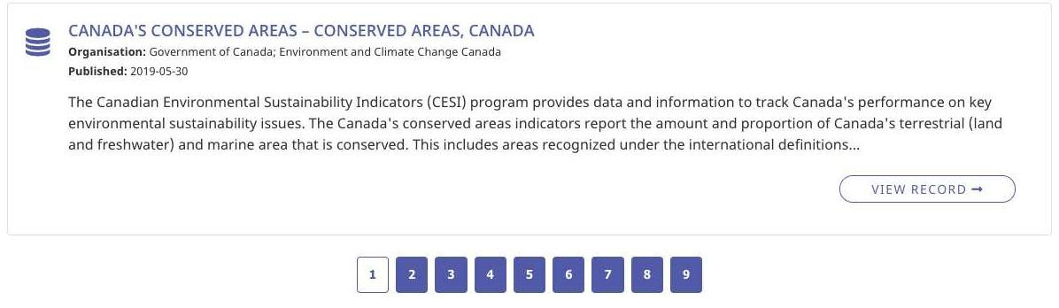

### [cgp-api-search]

**Description:**

Displays a search bar which submits a search to the CGP APP

**Parameters:**

| **Name** | **Description** | **Valid Params** | **Default** |
| --- | --- | --- | --- |
| lang | Language to display result in | string ‘en’ | ‘fr’ | en |
| theme | Theme to filter results by | string  Valid theme name (e.g. ‘legal’) | none |
| keyword_only | Search by the specified keyword value* | string | none |
| placeholder | Search input placeholder text | string | 'Search GEO.CA' (en)  ‘Rechercher dans GEO.CA’ (fr) |
| btn_text | Search submit button text (for screen readers) | string | 'Search’ (en)  ‘Rechercher’ (fr) |

* If keyword_only is set to true insert the following hidden

<input type="hidden" name="keyword_only" value=”keyword_only">

**Example:**

[cgp-api-search lang=’en’ theme=’legal’ keyword_only=’’ placeholder=’Search CGP’ btn_text=’Go!’]

**Screenshot:**



## 

## 3 - Shortcode Detail

### [cgp-api-ft-data]

* API calls and results rendering are made using vanilla JavaScript
  + /wp-content/plugins/cgp-api-shortcodes/public/src/js/cgp-api-sc-ft-data.js